



**Learning Intentions (We are learning to...)**





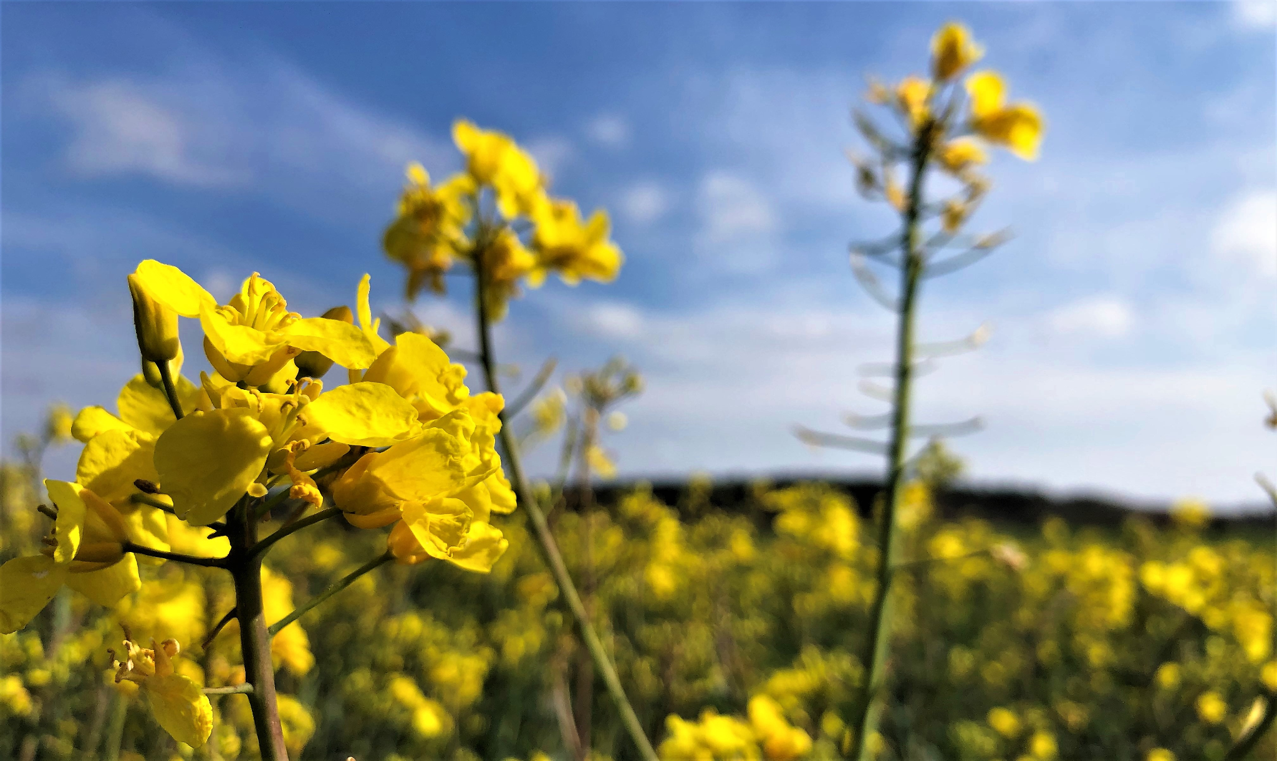

d





