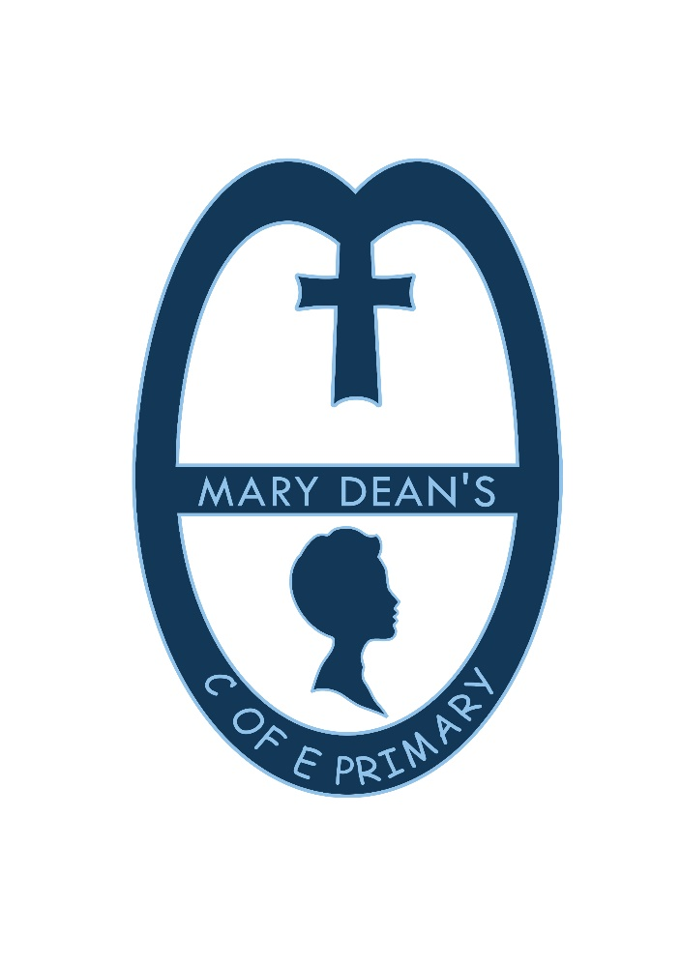

Mary Dean’s CE Primary School

Personal, Social, Health and Economic Education Policy

At Mary Dean’s CE Primary School PSHE (Personal, Social, Health and Economic Education) is a planned programme of learning where the children acquire the knowledge, understanding and skills they need to keep themselves healthy and safe.
PSHE provides the children with the building blocks in order for them to develop healthy, respectful relationships, focusing on family and friendships, in all contexts, including online. This sits alongside the essential understanding of how to be healthy.
As part of our whole school approach, PSHE develops the qualities and attributes that children need to manage opportunities, challenges and responsibilities as they grow up, enabling them to thrive as individuals, family members and members of society. By teaching pupils to stay safe and healthy, and by building self-esteem, resilience and empathy, our effective PSHE programme enables staff to tackle barriers to learning and raise aspirations for our pupils. At Mary Dean’s CE we have a two-year PSHE curriculum cycle.
We teach discrete PSHE lessons and filter PHSE skills throughout all aspects of school life.

Statement of intent

At Mary Dean’s CE Primary School, it is our intent to provide all children with a broad and balanced curriculum that aims to assist children and young people to prepare for adult life by supporting their physical, emotional and moral development, and helping them to understand and respect themselves and others, as well as forming and sustaining healthy relationships. This will be implemented by creating a programme of study that is bespoke to our school and all our children.
The two main core themes of our PSHE programme of study focuses on Relationships Education and Health Education. A third core theme, Living in the Wider World, is also an integral aspect of our curriculum.
Relationships Education. Families and people who care for me
Pupils will be taught the following:
• The importance of families for children when growing up, as they can provide love, security and stability
• The characteristics of healthy family life, commitment to each other, including in times of difficulty, protection and care for children and other family members, the importance of spending time together and sharing each other’s lives • That others’ families within the school or in the wider world may look different from their own, but those differences should be respected, and know that other children’s families are also characterised by love and care
• That stable, caring relationships, which may be of different types, are at the heart of happy families, and are important for children’s security
• growing up
• That marriage represents a formal and legally recognised commitment between two people which is meant to be lifelong
• How to recognise if family relationships are making them feel unhappy or unsafe, and how to seek help or advice from others if needed
Caring friendships
Pupils will be taught the following:
• The importance of friendships in making us feel happy and secure, and how people choose and make friends
• The characteristics of friendships, such as mutual respect, truthfulness, trustworthiness, loyalty, kindness, generosity, trust, sharing interests and experiences, and support with problems and difficulties
• That healthy friendships are positive and welcoming towards others, and do not make others feel lonely and excluded
• That most friendships have ups and downs, which can often be worked through so that the friendship can be repaired or even strengthened, and that resorting to violence is never right
• How to recognise who to trust and not to trust, how to judge when a friendship causes them to feel unhappy or uncomfortable, managing conflict, how to manage these situations and how to seek help or advice from others if needed
Respectful relationships
Pupils will be taught the following:
• The importance of respecting others, even when they differ from them (for example, physically, in character, personality or backgrounds), or make different choices or have different preferences or beliefs
• Practical steps they can take in a range of different contexts to improve/support respectful relationships
• The conventions of courtesy and manners
• The importance of self-respect and how this links to their own happiness
- That in schools and in wider society they can expect to be treated with respect by others, and should show this respect to others in return, including those in positions of authority
- About different types of bullying (including cyberbullying), the impacts of bullying, responsibilities of bystanders (primarily reporting bullying to an adult) and how to get help
- What a stereotype is, and how these can be unfair, negative or destructive
- The importance of permission-seeking and giving in relationships with friends, peers and adults

Online relationships
Pupils will be taught the following:
• That sometimes people behave differently online or pretend to be someone they are not
• That the same principles apply to online relationships as face-to-face relationships, including the importance of respect for others online (including when anonymous)
• The rules and principles for keeping safe online, recognising risks, harmful content and contact, and how to report them
• How to critically consider their online friendships and sources of information including awareness of the risks associated with people they have never met
• How information and data is shared and used online

Being safe
Pupils will be taught the following:
• What sorts of boundaries are appropriate in friendships with peers and others (including online contexts)
• About the concept of privacy and the implications of it from both children and adults; including that it is not always right to keep secrets in relation to being safe
• That each person’s body belongs to them, and the differences between appropriate and inappropriate/unsafe physical, and other forms of, contact
• How to respond safely and appropriately to adults they encounter (in all contexts, including online) whom they do not know
• How to recognise and report feeling bad or unsafe around an adult
• How to ask for advice or help for themselves or others, and to persist until they are heard That each person’s body belongs to them, and the differences between appropriate and inappropriate/unsafe physical, and other forms of, contact
• How to respond safely and appropriately to adults they encounter (in all contexts, including online) whom they do not know
• How to recognise and report feeling bad or unsafe around an adult
• How to ask for advice or help for themselves or others, and to persist until heard
• How to report concerns or abuse, and the vocabulary needed to do so
• About the dangers they may face, both in and around school and beyond, and how they can keep themselves safe.
• Where to get advice, e.g. family, school, other sources
• Water Safety – understanding the dangers of water and avoidance of these dangers.

Health Education
Mental well-being
Pupils will be taught the following:
• That mental wellbeing is a normal aspect of daily life, in the same way as physical health
• That there is a normal range of emotions (e.g. happiness, sadness, anger, fear, nervousness, surprise) and scale of emotions that all humans experience in relation to different experiences and situations
• How to recognise and talk about their emotions, including having varied vocabulary of words to use when talking about their own and others’ feelings
• How to judge whether what they are feeling and how they are behaving is appropriate and proportionate
• The benefits of physical exercise, time outdoors, community participation, voluntary and service-based activity on mental wellbeing and happiness Simple self-care techniques, such as the importance of rest, spending time with family and friends and the benefits of hobbies and interests
• Isolation and loneliness can affect children and so it is very important for children to discuss their feelings with an adult and seek support
• That bullying (including cyberbullying) has a negative and often lasting impact on mental wellbeing
• Where and how to seek support (including recognising the triggers for seeking support), including whom in the school they should contact if they are worried about their own or someone else’s mental wellbeing or ability to control their emotions (including issues arising online)
• It is common for people to experience mental ill health. For many of these people, the problems can be resolved if the right support is made available especially if accessed early enough

Internet safety and harms
Pupils will be taught the following:
• How the internet acts as an integral part of life for most people, with many benefits
• About the benefits of rationing time spent online, the risks of spending excessive time on electronic devices and the impact of positive and negative content online on their own and others’ mental and physical wellbeing
• How to consider the effect of their online actions on others and know how to recognise and display respectful behaviour online and the importance of keeping personal information private
• Why social media, some computer games and online gaming, etc. are age restricted
• That the internet can also be a negative place where online abuse, trolling, bullying and harassment can take place, which can have a negative impact on mental health How to be a discerning consumer of information online, recognising that information (including that from search engines) is ranked, selected and targeted
• Where and how to report concerns and get support concerning issues online

Physical health and fitness
Pupils will be taught the following:
• The characteristics and mental/physical benefits of leading an active lifestyle
• The importance of including regular exercise into daily and weekly routines and how to achieve this; for example, walking or cycling to school, a daily active mile or other forms of regular, vigorous exercise
• The risks associated with leading an inactive lifestyle (including obesity)
• How and when to seek support, such as which adults to speak to in school if they have health concerns
Healthy eating
Pupils will be taught the following:
• What constitutes a healthy diet (including understanding calories and other nutritional content)
• The principles of planning/preparing a range of healthy meals
• The characteristics of a poor diet and risks associated with unhealthy eating (such as obesity and tooth decay) and other behaviours (such as the impact of alcohol on diet or health)
Drugs, alcohol and tobacco
Pupils will be taught the following:
• The facts about legal/illegal harmful substances and associated risks, including smoking, alcohol use and drug-taking

Health and prevention
Pupils will be taught the following:
• How to recognise early signs of physical illness, such as weight loss or unexplained changes to the body
• About safe/unsafe exposure to the sun, and how to reduce the risk of sun damage, including skin cancer
• The importance of sufficient good quality sleep for good health and that a lack of sleep can influence weight, mood and ability to learn
• About dental health and the benefits of good oral hygiene and dental flossing, such as regular check-ups at the dentist
• About personal hygiene and germs including bacteria, viruses, how they are spread and treated, and the importance of handwashing
• The facts and science relating to allergies, immunisation and vaccination
Basic first aid
Pupils will be taught the following:
• How to make a clear and efficient call to emergency services if necessary
• Concepts of basic first aid, for example dealing with common injuries, including head injuries Changing adolescent body Pupils will be taught the following:
• Key facts about puberty and the changing adolescent body, particularly from age 9 through to age 11, including physical and emotional changes
• About menstrual wellbeing and key facts concerning the menstrual cycle
Department for Education statutory guidance states that from September 2020, all primary schools must deliver relationships and health education whereby parents cannot withdraw their child from this. The school will work with parents throughout the year and will ensure that parents are routinely kept informed about their right to withdraw their children from sex education (but not relationships or health education). The school ensures that pupils are also involved in the creation of this policy through termly feedback, suggestion forms and/or class discussions.
Implementation through Teaching and Learning
The school seeks to provide a safe, secure learning environment for PSHE that enables children and young people to gain accurate knowledge, develop their own values and attitudes, and develop skills to grow into happy confident successful adults.
At the beginning of each year, every class sets ground rules that children must follow during PSHE lessons. This creates a safe and supportive learning environment and allows children to feel comfortable and to speak openly and honestly.
After talking with pupils, we believe that children prefer asking questions anonymously (depending on the topic) and therefore we will enable pupils to raise anonymous questions by a variety of methods suited to the age and stage of the pupils These questions can then be answered by planning it into further learning. School will contact home if a child asks a questions that is not age appropriate to agree whether the question will be answered by parents, school staff or jointly.
At Mary Dean’s CE Primary School we promote the needs and interests of all pupils, irrespective of gender, culture or background and all teachers take into account the children’s age, ability and readiness. P.S.H.E will be provided through discreet curriculum time, assemblies, class discussions/circle time, as and when issues arise, ensuring time is made within the curriculum to meet the needs of the children and through extra-curricular activities. These include mental health awareness week, Bikeability (which we will use external contributors) safer internet day and walk or scoot to school week.
We respect pupils’ unique starting points by providing learning that is suitable to their level, taking into account their age, maturity and how emotionally secure they are. PSHE is taught by teachers and is mapped and planned out effectively to enable children to reach their full potential. PSHE lessons are weekly. However, incidental learning often takes place throughout the day, both outside on the playground and within the classroom.

Early Years and Foundation Stage
In Early Years, PSED (Personal, Social and Emotional Development) is a prime area of learning therefore an integral aspect of daily planning, teaching and learning.
• Making relationships
• Self-confidence and self-awareness
• Managing feelings and behaviour
Planning is child led to reflect the interests of the children and the needs of the school. Children take part in circle time and discuss topics and themes that are at their level. Teachers look at the three core themes and take aspects of these to inform their planning. PSED is a fundamental building block in a child’s development and underpins the whole curriculum.
Key Stage One and Two.
Within Key Stage One and Two PSHE lessons are often more structured and follow the scheme of work that is in place. This follows the three core themes which have been adapted specifically for the children at Mary Dean’s CE Primary School. Children have the opportunity to form and share opinions, value differences, recognise feelings and emotions as well as identify what makes relationships healthy.
Through teaching of Relationships and Health Education, we are enabling our children to well-rounded members of society, who can make a positive contribution to their community.
British Values
As a school we promote British values ensuring that our children leave school prepared for life in modern Britain. We support the values of democracy, rule of law, individual liberty, mutual respect and tolerance of different faiths and beliefs. Through aspects of school life such as voting for school council members, assemblies and discrete PSHE lessons, these values are embedded within our curriculum. We plan assemblies and lessons to teach the children about our values, respecting similarities and differences, tackling stereotypes and understanding why some people discriminate. We aim to empower children to have a voice and to stand up against discrimination, valuing equality, tolerance and mutual respect.

Implementation through Assessment, Recording, Reporting and Monitoring
Teachers assess the children’s work in PSHE by making informal judgements as they observe them during lessons. We have clear expectations of what the pupils will know and understand at the end of each year and key stage. Assessment should offer the children the opportunity to reflect on their own progress.
Shared Big Books are used to record some of the learning in PSHE or individual recording.
The PSHE subject leader is responsible for monitoring the standards of children’s work and the quality of teaching. The subject leader will monitor plans, teaching and learning in order to evaluate strengths and weaknesses in the school and indicate areas for improvement.
The subject leader will regularly evaluate the scheme of work to ensure that the needs of the pupils are being met and that there is progression and continuity of learning through the school.

Implementation through inclusion, including meeting the needs of SEND pupils
Our teachers provide learning opportunities matched to the individual needs of all children including those with special educational needs and disabilities. PSHE is taught inclusively to all children regardless of their race, religion and gender, whilst at the same time addressing the need for equal opportunity. The PSHE curriculum is in line with the single equality duty policy. Staff will ensure that no judgement will be passed on the lifestyles and choices made by others. If a safeguarding issue is raised, staff are required to follow the correct safeguarding procedure and safeguarding policy.
Implementation through Professional Development and Training
The PSHE subject leader ensures they are kept informed of relevant changes to aspects of PSHE by attending local cluster meetings, and PSHE network meetings.
The subject leader will support colleagues in the teaching of PSHE by giving them information about current developments in the subject and providing a strategic lead and direction for the subject in school.
Impact
Developing our children as happy, confident and resilient individuals is at the heart of all that we do at Mary Deans. Our school’s visions, aims and values detail this, and our school motto-A school family, learning for life in all its fullness- encapsulates the heart of our PSHE teaching. Through assessment, observations and discussion, we can see the impact of our PSHE curriculum on our children. They are caring, respectful, aspirational and confident individuals who are able to:

- Interact positively with each other and with adults in our school community
- Understand how they are able to make a positive contribution to our school community
- Recognise their own successes and celebrate those that others achieve
- Express their opinions in a respectful manner, showing an understanding that everyone has the right to express their thoughts as long as this does not harm others
- Keep themselves safe and make sensible decisions to do so, including staying safe online
- Celebrate their own identity and develop personal interests that allow them to express their own individuality
- Recognise and respect diversity and celebrate our differences
- Recognise and apply the British Values of Democracy, Tolerance, Mutual Respect, Rule of law and Individual Liberty
- Understand the physical aspects involved in SRE at an age appropriate level and have a positive body image

Links to other relevant policies
• Behaviour
• Anti-bullying
• Child Protection and Safeguarding
• Online safety
• SEND inclusion
• Single Equality Duty Act

