Mary Dean’s CE Primary School - Year 1 & 2: Plants - Spring 2024 cycle 2
Lifecycle of a plant | Parts of a plant | Vocabulary Dozen
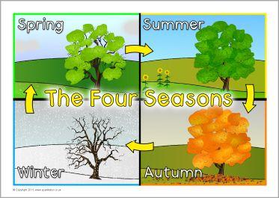  A tree through the seasons | 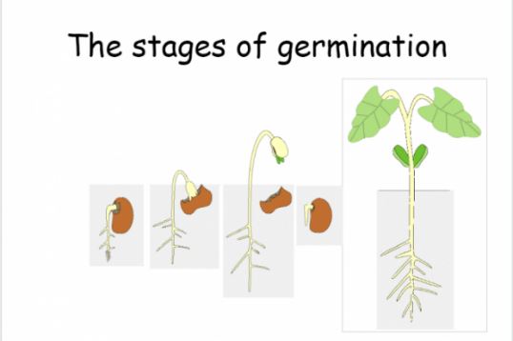  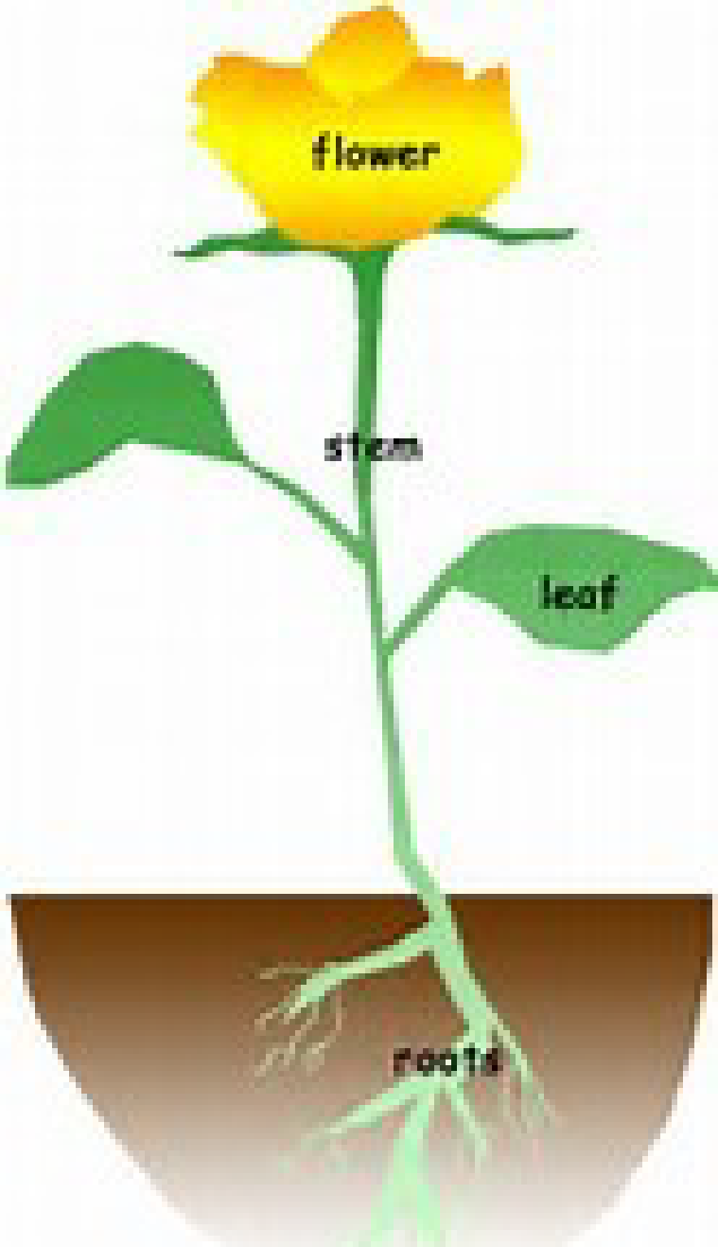  Germination  The seed When it is The shoot  fills with water warm enough grows above  and splits and it begins to ground and  a shoot appears make roots makes leaves | plant A living thing that usually grows from the ground.  flowers The part of a plant that has petals and that makes fruit or seeds  seed The part of a flowering plant that can develop into a new plant.  leaves The green, flat parts of a plant or tree that grow from the stem or branch.  stem The main part of a plant that grows up from the ground and supports the branches, leaves, flowers, or fruits that may grow from it.  roots The part of a plant that usually grows underground. Roots take up water and nutrients and hold the plant in the soil.  life cycle Continue series of changes showing the life of something  germination To start or cause to start growth; sprout.  evergreen A plant or tree that keeps its leaves all year.  deciduous A tree that loses its leaves in Autumn and grows new ones in Spring.  scattered Move in various random directions  seasons One of the four parts of the year; spring, summer, autumn and winter.

