Vocabulary dozen
Allah | The name Muslims call their God.
leader | A person who leads a group of people.
Mosque | A building where Muslims go to pray.
Muslim | A person who follows Islam.
Holy Qur’an | A very special book for Muslims.
Arabic | The language the Qua’ran is written in.
Prophet | A religious leader who passed on God’s teachings, like the Prophet Muhammed.
Arabic calligraphy | The special handwriting design used to draw symbols about Allah and messages from the Qua’ran.
Sacred | Something that is special to a religion.
wudu | Washing hands, mouth, nostrils, arms, head and feet before prayer.
Shahadah | The Muslim belief and promise that there is only one God, Allah.
subha | Prayer beads.
minaret | A tower connected to a Mosque, used for the call to prayer.
empathy | Showing an understanding of how people feel.

Year 1/2 RE. Cycle 2. Spring Term 1 Who is Muslim and how do they live?

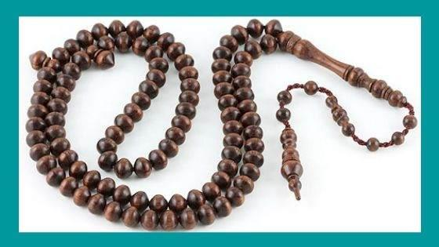
- star and crescent Mosque subha
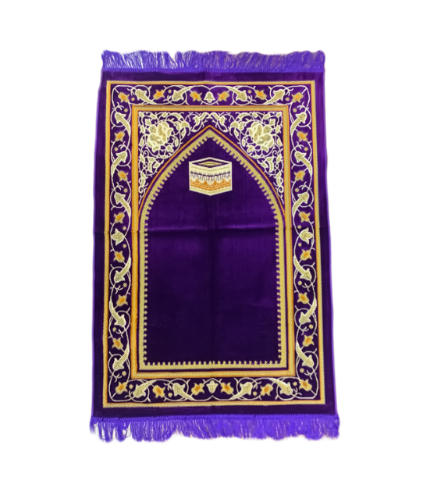
- symbol of Islam prayer beads

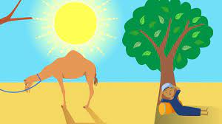
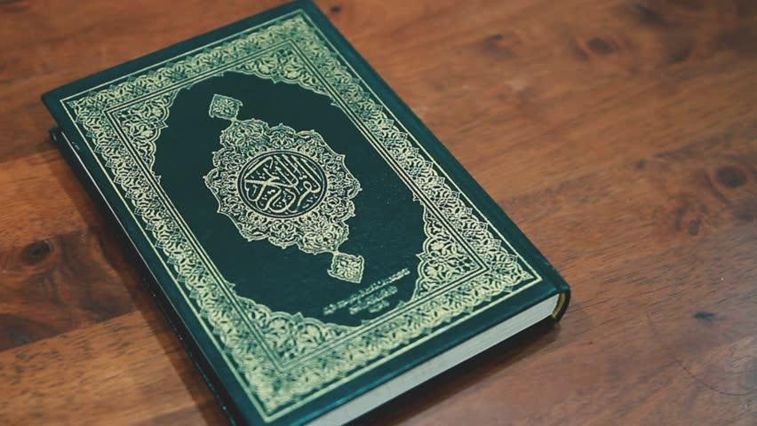

prayer mat The ants and the crying camel The Holy Qur’an

Week 1 | Week 2 | Week 3 | Week 4 | Week 5 | Week 6
Can I understand that Muslims believe in Allah as the one true God?  To know that Muslims are followers of the religion Islam and their God is called Allah. | Can I find out about the Shahadah and how this is the most important belief for Muslims?  Identify some of the key Muslim beliefs about God found in the Shahadah and the 99 names of Allah and give a simple description of what some of them mean. | Can I say why the stories of the Prophet Muhammed are important to Muslims?  Give and share examples of how stories about the Prophet show what Muslims believe about Muhammed. | Can I understand how Muslims worship and pray?  Give and share examples of how Muslims put their beliefs about prayer and worship into action. | Can I reflect on how Muslims live?  Think, talk, discuss and ask questions about Muslims beliefs and ways of living. | 1.5 Why does Easter matter to Christians?  (salvation)  Can I say what examples of new life I will find in the spring?
Outcomes for unit:
Make sense of belief | Understand the impact | Make connections
- Recognise that loving others is important in lots of communities  - Say simply what Jesus and one other religious leader taught about loving other people | - Give at least two examples of a way in which Christians show their belief in God as loving and forgiving (e.g. by saying sorry, by seeing God as welcoming them back; by forgiving others).  - Give an example of how Christians put their beliefs into practice in worship (e.g. by saying sorry to God) | - Think, talk and ask questions about whether they can learn anything from the story for themselves, exploring different ideas.  - Give a reason for the ideas they have and the connections they make.

